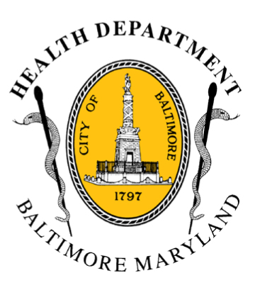
BCHD PRESS RELEASE
Baltimore City Health Department
1001 E. Fayette Street • Baltimore, Maryland 21202
Stephanie Rawlings-Blake, Mayor
Leana Wen, M.D., Commissioner of Health

FOR IMMEDIATE RELEASE

Media Contact: Michael Schwartzberg, PIO
O: (443) 984-2623 C: (443) 462-7939 E: michael.schwartzberg@baltimorecity.gov
With Half of the City’s Hypothermia Deaths Involving Alcohol Intoxication, Health Commissioner Issues Warning:
Alcohol and Cold Temperatures Do Not Mix And Can Be Deadly

BALTIMORE, MD (March 6, 2015) - Baltimore City Health Commissioner Leana Wen, M.D. is reminding Baltimoreans of the dangers of alcohol use during cold weather.

Baltimore remains under a Severe Code Blue declaration through 12 p.m. Saturday; the wind chill this evening will be around zero degrees and temperatures are expected to remain dangerously cold through approximately lunchtime on Saturday. There have been 8 deaths in Baltimore due to hypothermia this season and 31 statewide. Alcohol intoxication was a contributing factor in half of the deaths in Baltimore.

“Drinking alcohol can be life-threatening for individuals in temperatures that are this low,” Dr. Wen said. “People become intoxicated and fall asleep outdoors. When the temperature is this low, they can die. We are encouraging everyone to stay indoors if possible. If people must go outside, we urge them to dress warmly and avoid alcohol.”

Baltimore officials are especially concerned about the city’s most vulnerable residents - the elderly, children, people with chronic medical conditions, and homeless individuals.

An additional shelter at the War Memorial Building will remain open for individuals in need of protection from the weather from 6 p.m. this evening through 10 a.m. Saturday, and again from 6 p.m. Saturday through 10 a.m. Sunday.

- more-

2-2-2

The Health Commissioner may declare a Code Blue alert when temperatures, including wind chill, are expected to be 13˚F or below or when other conditions are severe enough to present a substantial threat to the life or health of vulnerable Baltimore citizens. Code Blue indicates an increased risk for cold injuries or even death for those exposed to low temperatures.

During a Code Blue, public and private shelters are available with extended services and assistance is available for those with no heat or electricity. The Mayor’s Office of Human Services operates a 24-hour Housing & Resource Center for men and women at 620 Fallsway with 60 additional spaces available for residents seeking meals and sleeping quarters. In addition, Baltimore City's 13 senior centers will have free emergency meals available.
Cold Weather Statistics For Baltimore
Winter Season | Code Blue Days Declared | Hypothermia-Related Deaths
2014-15 | 32 | 8
2013-14 | 34 | 4
2012-13 | 10 | 5
2011-12 | 11 | 3
- 2014-15 stats are season to date and include the declaration through March 7.

Cold Weather Tips for Staying Healthy:
- Wear multiple layers of loose-fitting clothing.
- Always wear a head covering, like a hat and/or scarf, when outdoors.
- Drink plenty of fluids and avoid alcoholic beverages.
- Protect yourself against falls in icy or snowy conditions
- Check on those who are children, the elderly and/or chronically ill.
- Provide appropriate shelter for domestic animals.

Other Tips For Keeping Safe in Cold Weather:
- Keep space heaters and candles away from flammable materials, such as curtains, furniture and loose clothing.
- Check your carbon monoxide detector and make sure it’s working.
- Do not use prohibited heat or power sources, such as stoves or generators. They may cause fire or carbon monoxide poisoning.
- Do not leave your car running in a closed space such as a garage.

Residents are encouraged to contact 311 if a neighbor is without heat or power so that city agencies can assist them. For more information with energy assistance, individuals may contact one of the regional Community Action Partnership centers in Baltimore or call the Office of Home Energy Programs at 410-396-5555. Additional cold-weather resources for the public including a listing of city and private shelters, is available at http://health.baltimorecity.gov/. For other cold-related inquiries and service requests, or to find a nearby homeless shelter, residents can call 211.
###

